A close up of a piece of paper

Description generated with high confidence

Ninong & Ninang

Hazel A. Tana

Rogeto T. Cusong

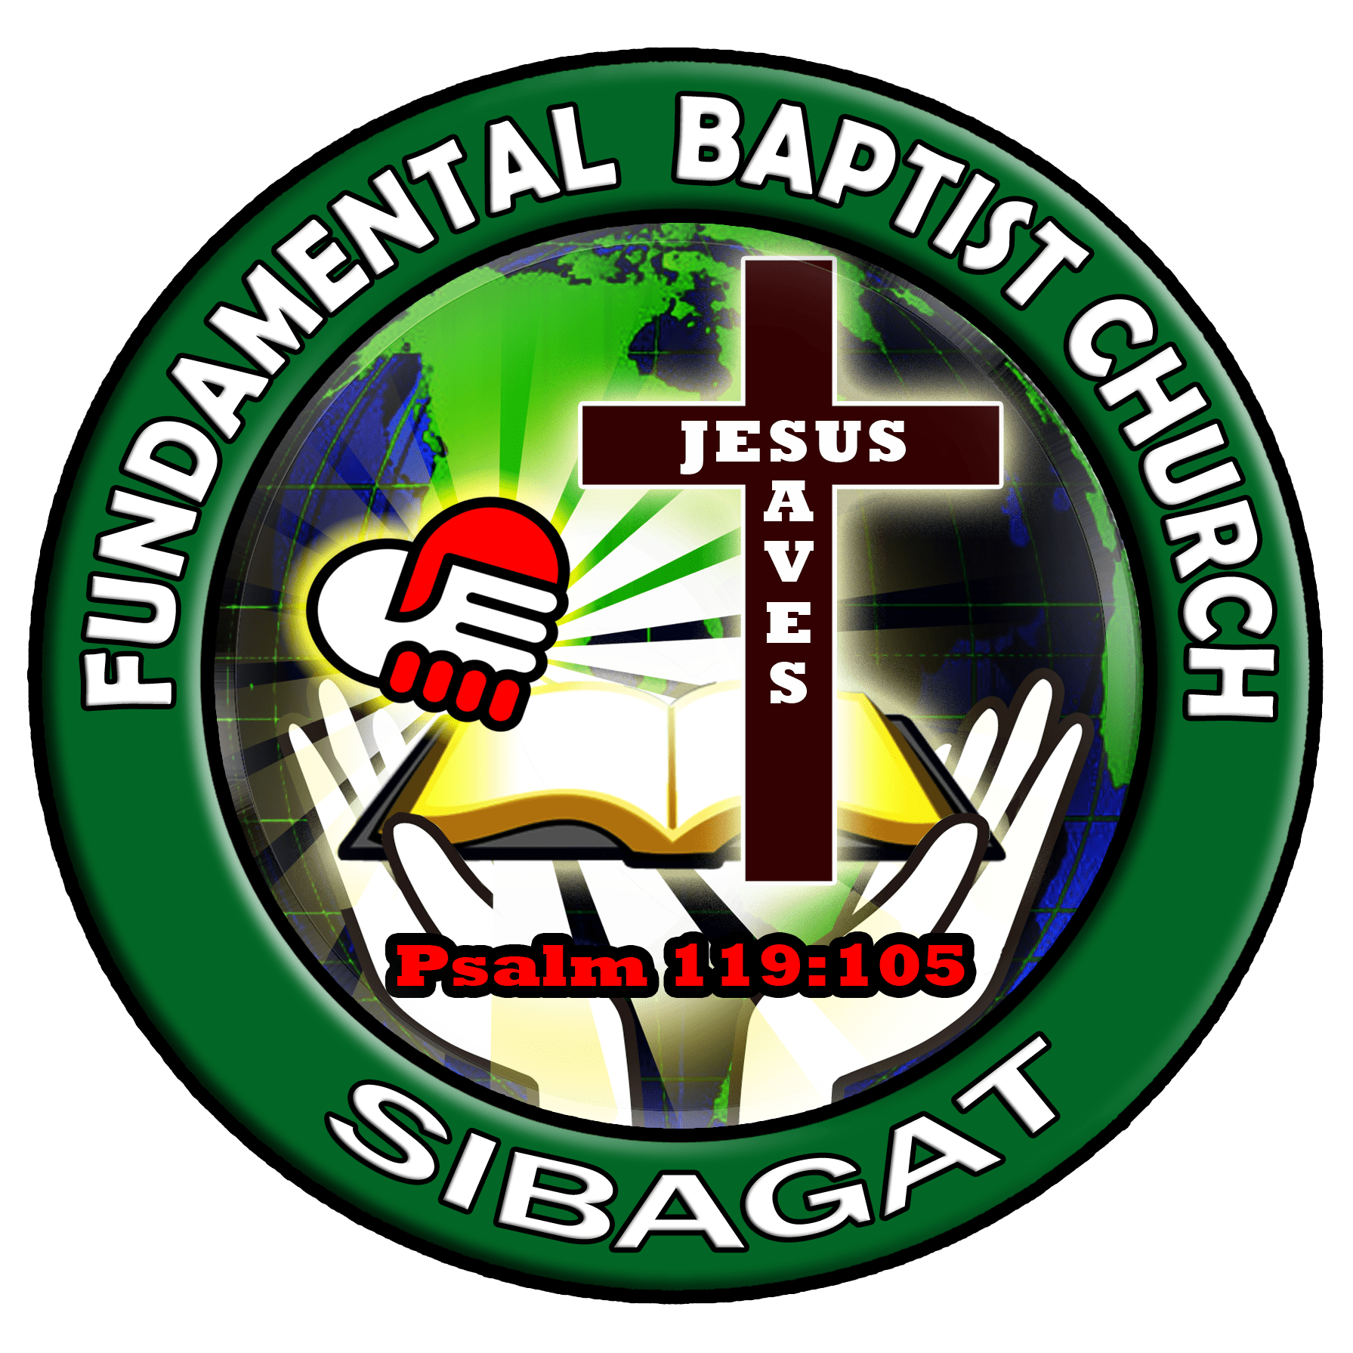



*"Children are a heritage from the Lord, offspring a reward from him.".*

*Psalm 127:3*